University of Mumbai
Kisaan Bandhu - A Farmer Grain
Assistant Application

Submitted at the end of semester VII in partial fulfillment of requirements
For the degree of
Bachelors in Technology
by
Meet Bhanushali - 1711005

Govinda Patel - 1711038

Parth Sheth - 1711055

Shailesh Upadhyay - 1711061

Guide
Prof. Rajni Pamnani

Department of Computer Engineering
K. J. Somaiya College of Engineering, Mumbai-77
(Autonomous College Affiliated to University of Mumbai)
Batch 2017 -2021
K. J. Somaiya College of Engineering, Mumbai-77
(Autonomous College Affiliated to University of Mumbai)

Certificate

This is to certify that the dissertation report entitled Kisaan Bandhu - A Farmer Grain Assistant Application submitted by
- Meet Bhanushali
- Govinda Patel
- Parth Sheth
- Shailesh Upadhyay

at the end of semester VII of LY B. Tech under Guidance of Prof Rajni Pamnani, is a bona fide record for partial fulfillment of requirements for the degree of Bachelors in Technology in Computer Engineering of University of Mumbai

_________________ _____________________
Guide Head of the Department
_________________
Principal

Date:
Place: Mumbai-77

K. J. Somaiya College of Engineering, Mumbai-77
(Autonomous College Affiliated to University of Mumbai)

Certificate of Approval of Examiners

We certify that this dissertation report entitled Kisaan Bandhu - A Farmer Grain Assistant Application is bona fide record of project work done by
- Meet Bhanushali
- Govinda Patel
- Parth Sheth
- Shailesh Upadhyay
during semester VII.
This project work is submitted at the end of semester VII in partial fulfillment of requirements for the degree of Bachelors in Technology in Computer Engineering of University of Mumbai.

___________________________
Internal Examiners

____________________________
External/Internal Examiners

Date:
Place: Mumbai-77
K. J. Somaiya College of Engineering, Mumbai-77
(Autonomous College Affiliated to University of Mumbai)

DECLARATION
We declare that this written report submission represents the work done based on our and / or others’ ideas with adequately cited and referenced the original source. We also declare that we have adhered to all principles of intellectual property, academic honesty and integrity as we have not misinterpreted or fabricated or falsified any idea/data/fact/source/original work/ matter in my submission.
We understand that any violation of the above will be cause for disciplinary action by the college and may evoke the penal action from the sources which have not been properly cited or from whom proper permission is not sought.
______________________________  Signature of the Student  _______________________________  Roll No. | ______________________________  Signature of the Student  _______________________________  Roll No.
______________________________  Signature of the Student  _______________________________  Roll No. | ______________________________  Signature of the Student  _______________________________  Roll No.

Date:
Place: Mumbai-77

Abstract
As we know that India’s GDP has a major share of the agricultural tasks and activities (around 14-16%), it becomes very important to improvise in the agricultural sector and maintain its sustainability in the fast growing market. But due to lack of advancements in this sector there is a transition seen in the farmers count in which many of them have opted to stop their farming work and moved on to some other sector. Hence we have chosen this project as it is a step towards the overall agricultural sector development by helping the farmers gains what they deserve.
Currently the scenario is such that the farmers sell their products to the dealers which then sell these products to the final buyers or some more small retailers and dealers. Due to this extra addition of the dealers in the cycle the final price of the product sold to the common man is higher than the expectation of the public and actual price which the product has. So our application will enable the farmer to directly reach the buyers hence cutting out the extra cost due the increase in the cycle due to the profit margins of the middle men. Also the entire profit made by selling the product is received by the farmer.
This is an application which is mainly used by farmers after crop season who need some source of platform to directly reach the buyers by eliminating the dealers in between the cycle which take the major share of the profit and finally the share which the farmer has for his part is not enough.

Key words: GDP , Market , Production chain cycle

Table of Contents
1. Introduction 8
1.1. Background 8
1.2. Problem Definition 9
1.3. Motivation 9
1.4. Scope of Project 9
1.5. Stakeholders 9
2. Literature Survey 10
2.1. Literature Survey 10
3. Overall Decription 13
3.1. Product Perspective 13
3.2. Product Functions 14
3.3. Operating Environment 15
3.4. Design and Implementation Constraints 15
3.5. Assumptions and Dependencies 15
4. Software Requirements Document 16
4.1. User Interfaces 16
4.2. Hardware Interfaces 18
4.3. Software Interfaces 18
4.4. Communications Interfaces 18
4.5. System Features 19
4.5.1. SF1 19
4.5.2. SF2 19
4.5.3. SF3 19
4.5.4. SF4 19
4.5.5. SF5 19
4.5.6. SF6 19
4.5.7. SF7 20
4.5.8. SF8 20
4.6. Other Nonfunctional Requirements 20
4.6.1. Performance Requirements 20
4.6.2. Safety Requirements 20
4.6.3. Security Requirements 20
4.6.4. Software Quality Attributes 20
5. Project Design 22
5.1. Proposed System Block Diagram. 22
5.2. Proposed Methodology 23
5.2.1. Sell and Buy of the product 23
5.2.2. Contract based sales 23
5.3. UML Diagrams 24
5.3.1. Class Diagram 24
5.3.2. Use Case Diagrams 24
5.4. Identified Risks 25
5.4.1. Risk : 25
5.4.2. Issues : 26
5.4.3. Challenges : 26
5.4.4. Constraints : 26
6. Implementation Details 27
6.1. Java 27
6.2. Flutter 27
6.3. Python 28
6.4. API 28
6.5. Node.js 28
6.6. MongoDB 29
6.7. Google Maps(Geo-Locator) 29
6.8. Operating Environment 29
6.8.1. Operating System : Windows/MAC/Linux and Android 29
6.8.2. Database : MongoDB(NoSQL) 29
6.8.3. Platform : Flutter, Node.js, Python 29
6.8.4. Software : postman, emulator, git, VS Code, Android Studio 29
6.9. Hardware Requirements : 30
6.10. Some of the temporary implementation screenshots until November end. 30
7. Conclusion 31
7.1. Conclusion 31
7.2. Future Scope 31
8. Bibliography 32
Chapter 1
Introduction
This chapter sheds light on the introduction of the project. The brief idea about the project, the techniques and tools required to carry out the project. The scope, and the general outlook of the project is discussed here.

  - Background
Kisaan Bandhu will enable the farmer to directly reach the buyers such as bulk buyers and supermarkets hence cutting out the extra cost due the increase in the cycle due to the profit margins of the Dealers. Also the entire profit made by selling the product is received by the farmer. This application will be mainly used by farmers after crop season who need some source of platform to directly reach the buyers by eliminating this system will also enable the farmers to directly receive some orders by large industries which will be contract based deals which will be managed by our application.

  - Problem Definition
Kisaan Bandhu is an application to empower the farmers by helping them reach the buyer through our application. The application will have a major role of connecting the end users via the application which will basically work as connector application for buying and selling the products which the farmers will directly put over the application for sale. Also we will implement a contract based feature wherein the farmers and the client company can have a production contract between themselves for which this application will be a mediator.

  - Motivation
As we know that India’s GDP has a major share of the agricultural tasks and activities (around 14-16%), it becomes very important to improvise in the agricultural sector and maintain its sustainability in the fast growing market. But due to lack of advancements in this sector there is a transition seen in the farmers count in which many of them have opted to stop their farming work and move on to some other sector. Hence we have chosen this project as it is a step towards the overall agricultural sector development by helping the farmers to gain what they deserve. Kisaan Bandhu will be mainly focused to provide a platform for the farmers to sell their products and get the maximum share of their produce.
Kisaan Bandhu will enable the farmer to directly reach the buyers such as bulk buyers and supermarkets hence cutting out the extra cost due the increase in the cycle due to the profit margins of the Dealers. Also the entire profit made by selling the product is received by the farmer. This application will be mainly used by farmers after crop season who need immediate sell of crops and transport to storages this system will also enable the buyers to directly place some bids on all agricultural products. Contract based deals which will be managed by our application.

  - Scope of Project
- First of all what we will try to achieve is to remove the unnecessary cycle in between the demand supply chain. We will try to create such a system where there will be direct buyers such as supermarts or a bulk buyer where we will directly supply the production from the farmers. Our cycle will try include maximum areas of production as we will also include transport services.
- The second task which will try to implement is to create a contract based production which will be provided by the companies. In this type what we are trying to achieve is that we will take certain contracts from the companies If the farmer decides to accept the contract then the company will provide the materials required for proper production. The company will also provide the details of the materials they will provide to the farmers for the proper production of the raw material.
  - Stakeholders
- Decision-makers: People with a higher authority, who control the flow of the project, in
terms of functionality, requirements. In this case, the Principal, Head of Department and
Project Mentor and team members.
- Influencers: People who may influence the decision of the project, only by a certain
margin. In this case, it would be the team members.
- End users: The final user of the software, who will use the project, the design has to be
done accordingly. In this case a disabled patient.

Chapter 2
Literature Survey
This chapter discusses about the various papers, articles referenced in preparation for undertaking this project. These items serve as a benchmark to enable this project to be undertaken.

The exploitation of the farmer and agricultural sector has been round the corner since the Pre - Independence times. THE AGRICULTURAL PRODUCE (GRADING AND MARKING) ACT, 1937 marked the initial exploitation phase of the agricultural sector by the British rulers. This act Allowed the central Government of the foregoing ruling governance to –
- fixing grade designations to indicate the quality of any scheduled article.
- defining the quality indicated by every grade designation.
- specifying grade designation marks to represent particular grade designations.
- authorising a person or a body of persons to mark articles with a grade designation mark.
- Any officer of the Central Government or a State Government can enter any premises at any reasonable time and make necessary inspection of the agricultural produce.
- An officer authorised under sub-section (1) of Section 3A may seize and detain any agricultural produce. Etc..

All of this provisions made in the ACT were exploiting the agricultural sector of India. This continued on and on even after Independence and still the agricultural sector is the most backward economical sector of the country.
This has led to the increase in the Mortality rate of the Farmers. According to a survey by the National Crime Records Bureau, between 1995 and 2014 more than 3,00,000 farmers have committed suicides in India. This is roughly equivalent to a staggering figure of one farmer suicide every 30 minutes. Only between 11772 suicides in 2013 and 12360 suicides in 2014 the percentage increase in the number of suicides is 5%. The main reason for the suicides is the overwhelming debts and the decreasing income due to exploitation. A majority of cotton producers of Andhra Pradesh committed suicides with a pending debt of around ₹1,00,000.
But among all these ill treatment before and after Independence, a ray of hope for the farmers and the agricultural sector was the development of AGRICULTURAL PRODUCE MARKETING COMMITTEE (APMC) .
One of the major causes of low income of the Indian farmers is the difficulty in marketing their crops. Due to the small size and scattered nature of agricultural holdings, the productivity per acre is low.So he has to rely on a number of middlemen (intermediaries) for the disposal of “his crops at cheap prices.
Marketing in agricultural produce is considered as an integral part of agriculture as agriculturist is made more eager to invest in this sector. It helps in reducing the charges for marketing service by eliminating the chain of middlemen and to have the minimum difference between the buying and the selling prices. Marketing becomes an important instrument in improving the income of the individual producers of all categories, apart from meeting the requirements of the customers.
The main directions in which marketing was modernized were:
- Institutionalizing of agricultural marketing by facilitating the formation of
Cooperative marketing societies
- Regulation of markets for various agricultural products designed to minimize or eliminate unfair trade practices
- Direct involvement of the State in the marketing of certain agricultural products.

The major functions of the APMC are: grant, renew, refuse, suspend or cancel license;
provide the necessary facilities; regulate and supervise the auctions; maintain and manage the
markets; regulate the sales, promote and organize grading and standardization of the
agricultural produce and ware housing facilities in the market area.
Recently in June,2020, a major step was taken in this direction by introducing the

Farmers (Empowerment and Protection) Agreement on Price Assurance and Farm Services Act, 2020.

This act empowered the farmers as it:
- Recognised farmers as an individual engaged in the production of farming produce by self or by hired labour or otherwise, and includes the Farmer Producer Organisation(a group of farmers registered under law).
- Allowed farmers to sign legal agreements with sponsors prior to the production of any farming produce of a predetermined quality.
- Made it legal and compulsion for the sponsors to bear the risk of output and any farming needs and pay the farmer for his work regardless of any loss or profit which the sponsor bears.

Another act in the same time period in June,2020 named as
Farmers’ Produce Trade and Commerce (Promotion and Facilitation) Act, 2020
also boasted the agricultural sector by the following points:
- It allowed farmers to have electronic trading and transaction platform where online buying and selling of farmer’s produce is allowed.

Chapter 3
Overall Description
This chapter discusses about the about the overall description of the project which also includes diagrams such as the workflow diagram and some product functionalities.

  - Product Perspective
As we know that India’s GDP has a major share of the agricultural tasks and activities (around 14-16%), it becomes very important to improvise in the agricultural sector and maintain its sustainability in the fast growing market. But due to lack of advancements in this sector there is a transition seen in the farmers count in which many of them have opted to stop their farming work and move on to some other sector. Hence we have chosen this project as it is a step towards the overall agricultural sector development by helping the farmers to gain what they deserve. Kisaan Bandhu will be mainly focussed to provide a platform for the farmers to sell their products and get the maximum share of their produce.
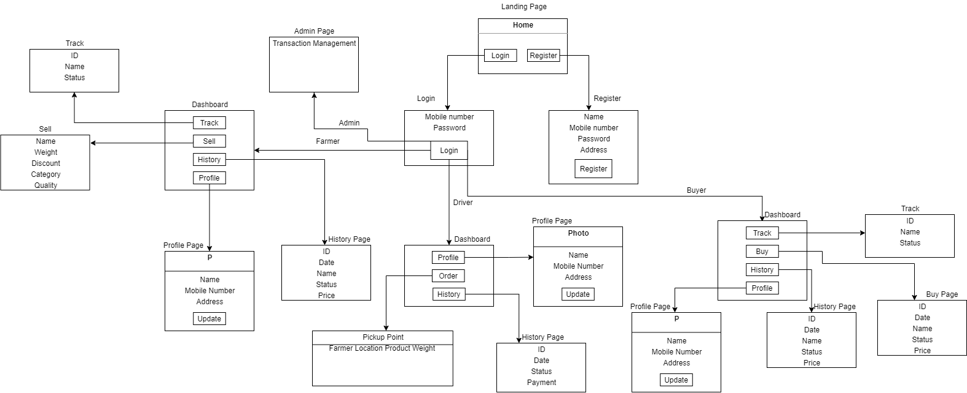

  - Product Functions
•User: Farmer
•Functions:Farmers are one of the end user who can post the products over the application.
- Sell products
- Track history
- Track current orders
- Profile

•User : Buyer
•Functions :Buyer is one of the end user who can buy the products over the application.
- Sell products
- Track history
- Track current orders
- Profile

•User : Driver (Transport service)
•Functions :
- Track history
- Track current orders
- Profile

  - Operating Environment
Operating Environment for Kisaan Bandhu is listed as below :
- Operating System : Windows/MAC/Linux and Android
- Database : MongoDB(NoSQL)
- Platform : Flutter, Nodejs, Python
- Software : postman, emulator, git, VSCode, Android Studio

Hardware Requirements :
- Processor : Pentium 4 and higher
- RAM : 1GB +
- Storage : 1GB +

  - Design and Implementation Constraints
- The most important factors determining whether customers return to an application are ease of use and the presence of user-friendly features. Usability testing is important for finding problems and improvements in an application. Methods for evaluating usability include heuristic evaluation, cognitive walkthrough, and user testing. Each technique has its own characteristics and emphasizes different aspects of the user experience.

- Pages details:
- Home/Landing Page
- Login Page
- Registration Page
- Profile Page
- Individual Dashboard Page
- Selling/Buying Product Page
- History Page
  - Assumptions and Dependencies
- Google Maps (Internet connectivity)
- Working API
- Location Services Enabled device
Chapter 4
Software Requirements Document
In this chapter, the different requirements of the system are discussed. It contains sections such as system functions, Interface requirements etc.

The link for the SRS Document is - SRS
  - User Interfaces
- Home/Landing Page
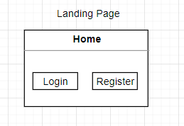
- Login Page
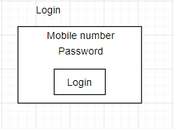
- Registration Page
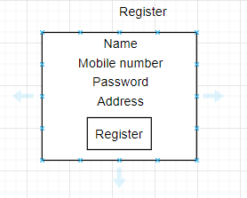

- Profile Page
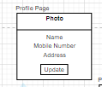
- Individual Dashboard Page
Buyer Dashboard
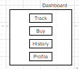

Farmer Dashboard
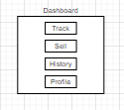

Driver Dashboard
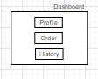
- Selling/Buying Product Page
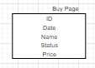
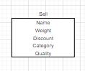
- History Page
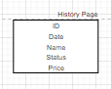

  - Hardware Interfaces
Server Side:
The API will be hosted on a web hosting server.
Client side:
- Android mobile
- Proper Internet Connectivity
- GPS (Location) enabled service

  - Software Interfaces
Server Side:
- Web server will accept all the requests from the client and respond accordingly.Database will be hosted centrally using a single storage system.
Client Side:
Android OS having version 5 and above.

  - Communications Interfaces
The HTTP or HTTPS protocol(s) will be used to facilitate communication between the client and server.

  - System Features
This section provides a requirement overview of the system.
    - SF1
Title - User Registration
Description - User can register in the application through mobile where the user must provide the required information.
Dependency - None
Result - User register successfully

    - SF2
Title - User Login
Description - User can Login the application through mobile where the user must provide the required information to successfully login.
Dependency - SF1.
Result - User Login successfully

    - SF3
Title - Sell product ( by Farmer)
Description - Farmers can sell the product via the application by listing their products over the application for sale.
Dependency - SF2
Result - Successfully listed the product for sale

    - SF4
Title - User Profile
Description - User can view and edit his/her profile in the application Dependency - SF2
Result - User profile changed/viewed successfully

    - SF5
Title - Track orders
Description - User can track the current orders which are placed and can get all the details regarding the status of the order.
Dependency - SF2 & SF3
Result - User will be able to track their orders successfully

    - SF6
Title - Track History
Description - Users can track their previous orders which are sold or bought and already completed and can get the status of those particular orders.
Dependency - SF2 & SF3
Result - User will be able to track their history successfully

    - SF7
Title - Buy Product ( Buyers)
Description - Users can buy the product via the application which are listed in the application for sale.
Dependency - SF2
Result - User will be able to buy products successfully

    - SF8
Title - track pickup orders (Drivers)
Description - The transport service driver will be able to track the pickup points from where the farmers will sell their products.
Dependency - SF2 & SF3
Result - Driver will able to track the pickup route successfully

  - Other Nonfunctional Requirements
    - Performance Requirements
- This system is for a smaller area initially and hence it should handle at least 200 users.
- The downtime for the application must be less than 5%.

    - Safety Requirements
- If there is extensive damage to a wide portion of the database due to catastrophic failure, such as a disk crash, the recovery method restores a past copy of the database that was backed up to archival storage (typically tape) and reconstructs a more current state by reapplying or redoing the operations of committed transactions from the backed up log, up to the time of failure.
    - Security Requirements
- System will use secured database
- Avoiding misuse of personal data of users such as GPS location.
- System will have different types of users and every user has access constraints.

    - Software Quality Attributes
      - Reliability
The system provides storage of all databases on redundant computers with automatic switchover. The reliability of the overall program depends on the reliability of the separate components. The main pillar of reliability of the system is the backup of the database which is continuously maintained and updated to reflect the most recent changes.

      - Maintainability
NoSQL is used for maintaining the database and the server takes care of the API’s. In case of a failure, a re-initialization of the program is recommended as soon as possible.

      - Availability
The system should be available at all times, meaning the user can access the application, only restricted by the down time of the server on which the system runs.

      - Portability
The technologies used are already system independent. The application is Android based. So The end-user part is fully portable and any system using any android version 5 and above should be able to use the features of the system.

Chapter 5
Project Design
In this chapter, different project design topics such as UML diagrams and block diagrams are included.

- Project Design
  - Proposed System Block Diagram.
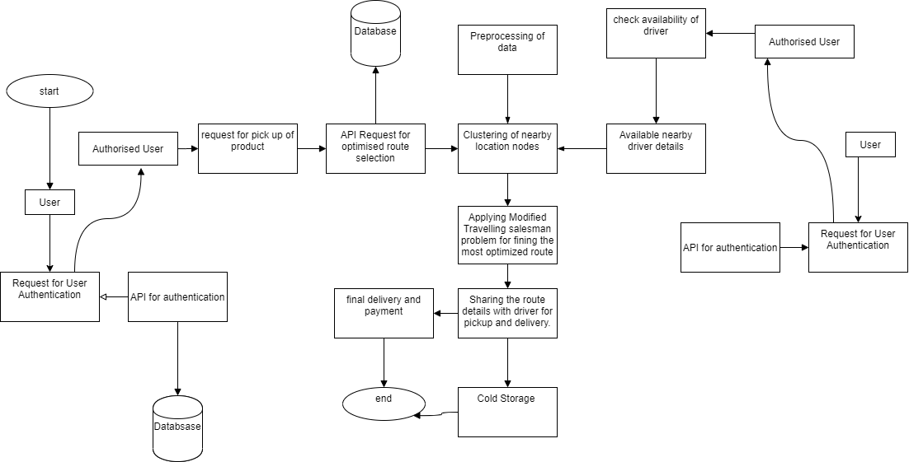
The link for above diagram is - Diagram

  - Proposed Methodology
    - Sell and Buy of the product
- Activity 1 - Farmer posts the product on the application
    - Authentication of the farmer via the Login into the application.
    - Posting of the product on the application
    - Filling the details of the product.
    - Final submission of the product for sale on the application
    - Tracking of the application for the product in the sale cycle.
    - Final status of the product
  - Activity 2 - Transportation of the product by the Driver
- Checking the availability of Driver for pickup
- Assigning list of pickup locations for driver.
- Deciding group of pickup location using clustering analysis based on pin code Using Modified Travelling Salesman Problem to predict the optimized route for pickup and distribution.
  - Activity 3 - Buying the product
    - Buyer places the bid for the product on the application
    - Using greedy approach for allotment amount of product
    - Accepting the payment for the product using the payment gateway.

    - Contract based sales
  - Activity 1 - Client
    - Details for the product to be grown
    - Quantity of the required product to be grown
    - Notifying farmers for the availability of a contract

  - Activity 2 - Assigning of the contract to the farmers by conditional mapping

  - UML Diagrams
    - Class Diagram
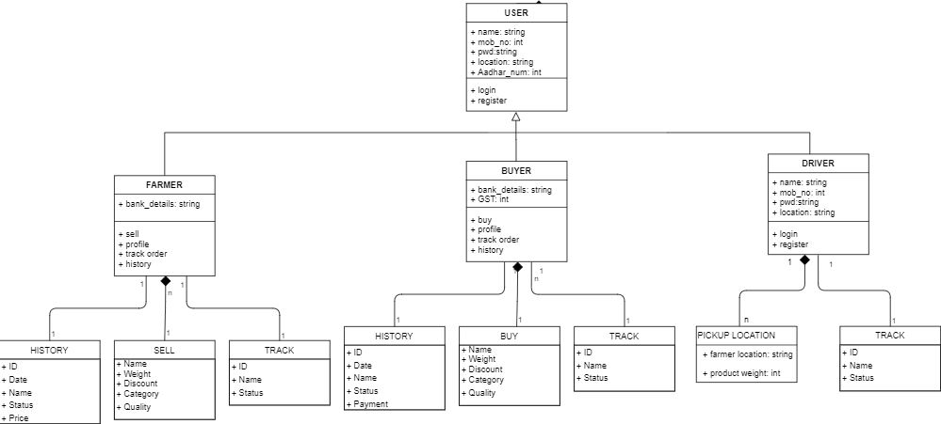

    - Use Case Diagrams
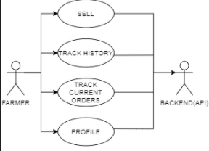
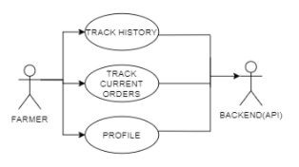
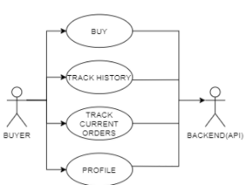
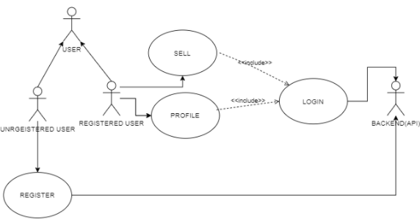

  - Identified Risks
    - Risk :
- Sensitive and personal information must be only accessed by authorised personnel.
For example while buying some product over application care should be taken such that confidential data of other users in the system isn’t revealed. Hence we have to devise a mechanism to ensure this as confidentiality is most important in a database system.
    - Issues :
- Farming has become a secondary profession looked as a symbol of primitiveness and people practicing it leaving it at a very alarming rate, soon this project will become obsolete as none will be left to use it.
- After amendment of the agriculture act 2020 protest may impose heavy taxes on deals outside of APMCS to make balance between deals in APMCS and deals outside it. That will make this project financially infeasible.
  - Since in future, as we have mentioned in future scope, we will try to predict the future demand of the seasonal produce and try to channelize their production to avoid price crash, we may face some environmental and societal hindrance from those who do not try change for the benefit of others as well but would rather stay with the primitive methods and activities.

    - Challenges :
- The main challenge is single/multiple JOINS in the database which may or may not give high accuracy.
- A challenge which we will face is to gain a good hold in the current market situation where people tend to generally avoid using some new application if it is not friendly and easy to use.
- Use of Travelling salesman problem for routing will not be able to give the most efficient route if the nodes are of extreme values.
- Another obstruction which we will face would be by the current dealers as we tend to remove this dealer cycle and hence they will try to hinder our smooth implementation.

    - Constraints :
- Currently supports only English language.
- Another technical constraint of our application will be that it will be majorly using GPS (Location services) for best working, so the users of our application must be having some source to update their location (if not by using GPS).

Chapter 6
Implementation Details
This chapter gives information of all the implementation details of the project such as the technologies used etc.

  - Java
We will be using Java as our main development language. The algorithm which we will be implementing will be written in Java. Java is the #1 programming language and development platform. It reduces costs, shortens development timeframes, drives innovation, and improves application services. With millions of developers running more than 51 billion Java Virtual Machines worldwide, Java continues to be the development platform of choice for enterprises and developers. Java is a class-based, object-oriented programming language that is designed to have as few implementation dependencies as possible. It is a general-purpose programming language intended to let application developers write once, run anywhere (WORA) meaning that compiled Java code can run on all platforms that support Java without the need for recompilation. Java applications are typically compiled to bytecode that can run on any Java virtual machine (JVM) regardless of the underlying computer architecture. The syntax of Java is similar to C and C++, but has fewer low-level facilities than either of them. The Java runtime provides dynamic capabilities (such as reflection and runtime code modification) that are typically not available in traditional compiled languages. As of 2019, Java was one of the most popular programming languages in use according to GitHub, particularly for client-server web applications, with a reported 9 million developer.

  - Flutter
We will be implementing our application in flutter framework. The main implementation tool of our application will be flutter. As flutter is used to develop applications which can run over IOS or android as well, we have chosen this as our basic framework. Flutter is an open-source UI software development kit created by Google. It is used to develop applications for Android, iOS, Linux, Mac, Windows, Google Fuchsia, and the web from a single codebase. The first version of Flutter was known as codename "Sky" and ran on the Android operating system.

  - Python
Python will be mainly used for implementation of backend code for API and other functionalities which we are providing. Python is an interpreted, high-level, general-purpose programming language. Created by Guido van Rossum and first released in 1991, Python's design philosophy emphasizes code readability with its notable use of significant whitespace. Its language constructs and object-oriented approach aims to help programmers write clear, logical code for small and large-scale projects. Python is dynamically typed and garbage-collected. It supports multiple programming paradigms, including procedural, object-oriented, and functional programming.

  - API
API will be mainly used in the backend implementation for pages such as login, registration, buying or selling the product, getting the location of the user, deciding the most optimized route for the delivery and pickup of goods etc. API is an application programming interface is a computing interface that defines interactions between multiple software intermediaries. It defines the kinds of calls or requests that can be made, how to make them, the data formats that should be used, the conventions to follow, etc.

  - Node.js
Node.js will be mainly used for collecting the responses from our application via the API and other inputs. Here the main work of Node.js will be to accept server side scripts and responses which the application will send for action. Node.js is an open-source, cross-platform, back-end, JavaScript runtime environment that executes JavaScript code outside a web browser. Node.js lets developers use JavaScript to write command line tools and for server-side scripting—running scripts server-side to produce dynamic web page content before the page is sent to the user's web browser. Consequently, Node.js represents a "JavaScript everywhere" paradigm,^{[6]} unifying web-application development around a single programming language, rather than different languages for server- and client-side scripts.
  - MongoDB
We have chosen MongoDB as our database where all the database management tasks such as transactions and storing will be done. It will be hosted online so that it can be accessible from anywhere. MongoDB is a cross-platform document-oriented database program. Classified as a NoSQL database program, MongoDB uses JSON-like documents with optional schemas. MongoDB is developed by MongoDB Inc. and licensed under the Server Side Public License (SSPL). MongoDB’s document model is simple for developers to learn and use, while still providing all the capabilities needed to meet the most complex requirements at any scale. We provide drivers for 10+ languages, and the community has built dozens more.

  - Google Maps(Geo-Locator)
Google maps will be mainly used for location services and collection of the location os the user for mainly determining the pickup point, optimized route for pickup and delivery, delivery point. Google Maps is a web mapping service developed by Google. It offers satellite imagery, aerial photography, street maps, 360° interactive panoramic views of streets, real-time traffic conditions, and route planning for traveling by foot, car, bicycle, air and public transportation.A Flutter geolocation plugin which provides easy access to platform specific location services (Fused Location Provider Client or if not available the Location Manager on Android and CL Location Manager on iOS).
Features :
- Get the last known location;
- Get the current location of the device;
- Get continuous location updates;
- Check if location services are enabled on the device;
- Calculate the distance (in meters) between two geo-coordinates;
- Calculate the bearing between two geo-coordinates;

  - Operating Environment
    - Operating System : Windows/MAC/Linux and Android
    - Database : MongoDB(NoSQL)
    - Platform : Flutter, Node.js, Python
    - Software : postman, emulator, git, VS Code, Android Studio

  - Hardware Requirements :
    - Processor : Pentium 4 and higher
    - RAM : 1GB +
    - Storage : 1GB +

  - Some of the temporary implementation screenshots until November end.
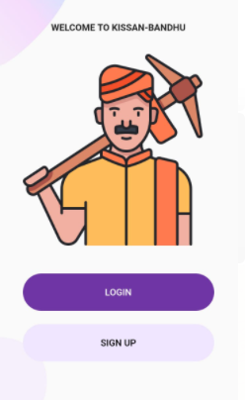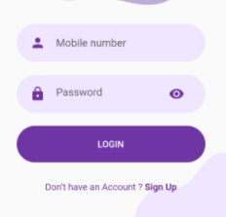
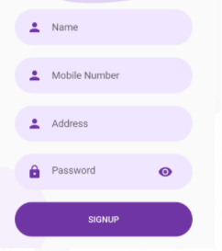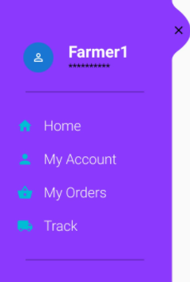

Chapter 7
Conclusion
This chapter gives the conclusion of the project , apart from this we also discuss the future scope of this project.

Conclusion
This project aims to reinvent the production and transactional wheel of buying and selling the agricultural products. Currently the project will try to reach the maximum area of the user base but due to some usability constraints will lead to restriction of the area where the product will make impact. It will be easy for the use by any layman as the application will try to avoid any complicated functionalities. Although the current prototype only allows limited functions, we hope the future will increase the number of functionalities and applications that can be used by the user. We hope to be an integral part of this research that will change lives and revolutionize the extent of independency the members of our agricultural society will achieve with this technology.

Future Scope
- Creating a network and chain of the farmers to make efficient production cycle.
- Creating a network of producers and consumers while maintaining supply chain among them.
- Better transparency of transaction using Block chain technology.
- Predicting the future demand of a particular product in and hence making shift in storage of the product by utilizing the empty rounds making the transportation cycles efficient.
- Predicting future demand of seasonal produces to avoid price crash in products during non-demanding seasons while maintaining profitable margin.

Chapter 8
Bibliography
- https://flutter.dev/docs
- https://docs.mongodb.com/
- https://expresses.com/en/5x/API.html
- THE FARMERS’ PRODUCE TRADE AND COMMERCE(PROMOTION AND FACILITATION) ORDINANCE, 2020
- Role of APMCs in Agricultural Marketing in India- A Study
- Farmers Suicides in India research paper
- Farmer Suicides in India - Trends across Major States, 1995–2011
- THE FARMERS’ PRODUCE TRADE AND COMMERCE (PROMOTION AND FACILITATION) ACT, 2020
- THE FARMERS (EMPOWERMENT AND PROTECTION) AGREEMENT ON PRICE ASSURANCE AND FARM SERVICES ACT, 2020
- THE AGRICULTURAL PRODUCE (GRADING AND MARKING) ACT, 1937

